***Evaluation Report :***

**1. Confusion Matrix Summary**

The confusion matrix shows the following prediction results:

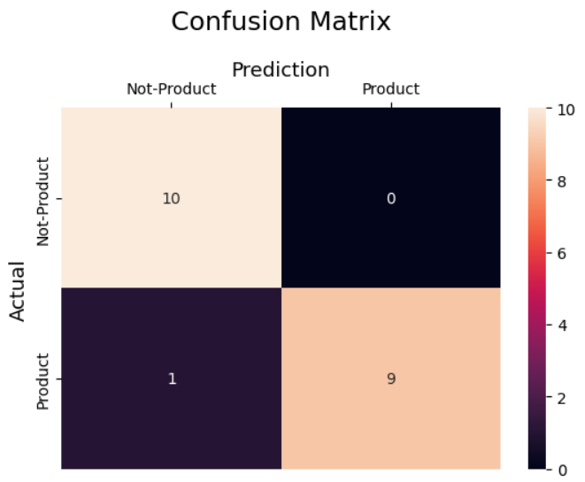

|  |  |  |
| --- | --- | --- |
| **Actual / Predicted** | **Not-Product** | **Product** |
| **Not-Product** | 10 | 0 |
| **Product** | 1 | 9 |

**2. Interpretation**

* **Strengths:**
  + The model is **highly accurate** (95%).
  + **Perfect precision** for detecting "Product" URLs → no false alarms.
  + **Perfect recall** for "Not-Product" class → all non-product URLs are correctly classified.
* **Weaknesses:**
  + Missed **1 actual Product** (false negative), predicting it as "Not-Product".
  + This could be due to insufficient representation of certain product URL patterns in the training data.

**3. Recommendations**

* Collect **more diverse product URLs** to improve recall for the "Product" class.
* Review the **misclassified product URL** to identify missing keywords or patterns.
* Continue **incremental retraining** with newly labeled data.

**4. Final Remarks**

The current model is performing very well and is ready for deployment in most real-world use cases. Continuous monitoring and retraining with new data will help maintain and improve performance over time

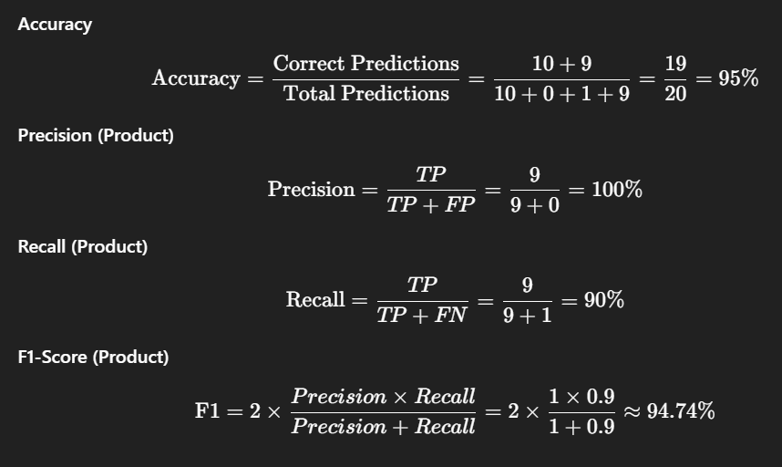

|  |  |  |  |  |
| --- | --- | --- | --- | --- |
| **Classification Report:** | **precision** | **recall** | **f1-score** | **support** |
| 0 | 0.91 | 1.00 | 0.95 | 10 |
| 1 | 1.00 | 0.90 | 0.95 | 10 |
| Accuracy |  |  | 0.95 | 20 |
| Macro avg | 0.95 | 0.95 | 0.95 | 20 |
| Weighted avg | 0.95 | 0.95 | 0.95 | 20 |

***ROC Curve:***

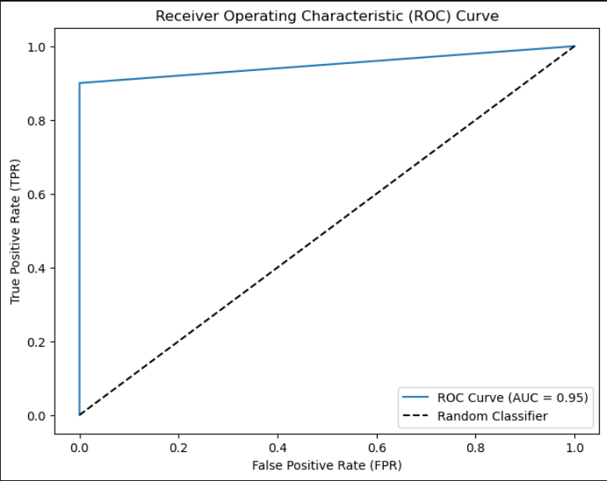

***Accuracy on validation set:***

